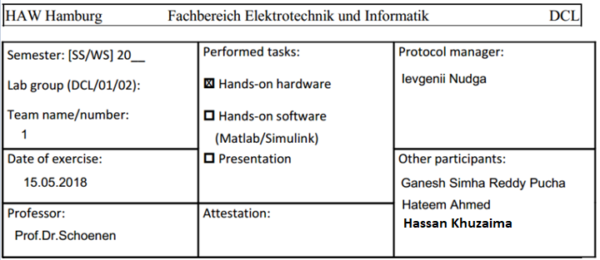

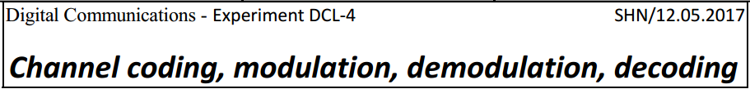

**Introduction**

In this lab 4, the main point is to use the knowledge on IQ modulation and IQ demodulation in the real experiment. The advanced signal generator is been used with frequency of 70 MHz therefore, the local oscillator i.e. carrier is also set to 70 MHz. The bit generator is set to a pseudo noise generator with maximum length. Initially, the modulation is set to QPSK and later to 16-QAM.

**Device list:**

* Advanced signal generator (Rohde&Schwarz SMIQ03B)
* Rohde&Schwarz SMY01
* Oscilloscope, 4 channel (Tektronix 3014B)
* Pseudo noise generator (K-Lab own development)
* Receiver box (Laborversuch AÜP3b)
* SDR hardware box (HackRF One)

**I/Q coherent modulation:**

Amplitude and phase can be modulated simultaneously and separately to convey more information than either method alone, but it is difficult to do. An easier way is to separate the original signal into a set of independent components or channels i.e. I (In-phase) and Q (Quadrature). The I/Q signals are known as Quadrature signals because they are 90 degrees apart in phase (1/4 cycle).

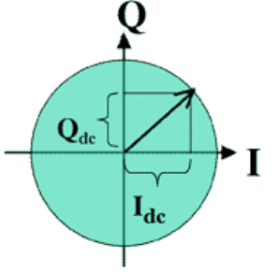 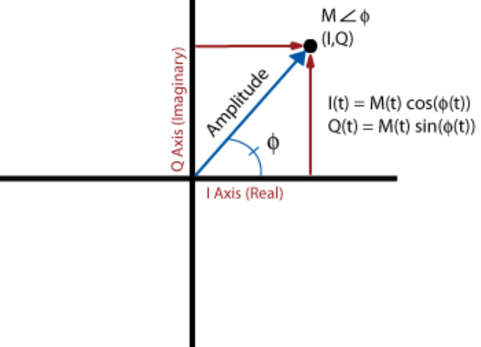

Figure 1: I/Q plane

A signal carrier generate by a local oscillator circuit is split into two paths. One path is delayed by an amount of time equal to ¼ of the carrier’s cycle time or 90 degrees. The two carriers are amplitude modulated, one by I signal and the other by Q signal. The output is a digitally modulated signal whose amplitude and phase are determined by the amplitude of the two modulating signals.

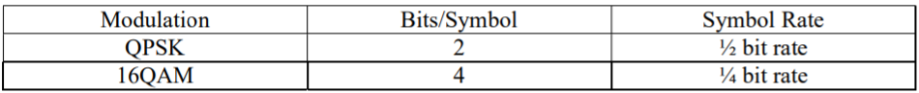

Table 1: QAM Modulation Techniques

**I/Q Demodulation:**

Any modulated RF signal can be converted into I & Q signals on basis of software define radio (SDR). IQ signals can easily be generated and analyzed in software, and proceed through ADC’s & DAC’s. The operation of an IQ-demodulator can be explained by representing its RF input signal SRF(t) as a combination of two double sideband modulated quadrature carriers:



As illustrated in Figure 2, the in-phase component I(t) and quadrature component Q(t) are baseband signals that can be viewed as inputs to an ideal IQ-modulator generating SRF(t).

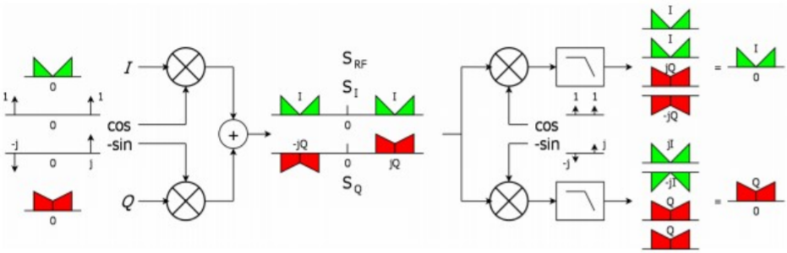

Fig. 2: Concept of IQ-modulation and IQ-demodulation

An IQ-demodulator achieves perfect reconstruction of I(t) and Q(t) by exploiting the quadrature phase relation between SI (t) and SQ(t).

**QPSK:**

The Quadrature phase shifting keying means the signal shifts among phase states that are separated by 90 degrees. The signal shifts in increments of 90 degrees from 45° to 135°, -45° (315°), or -135° (225°). The two carriers are combined and transmitted into four states.

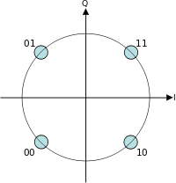

Figure 5: QPSK constellation plane

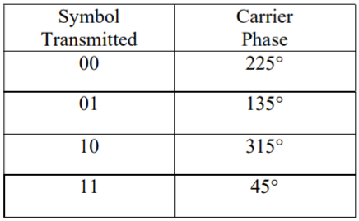

Table 2: QPSK constellation

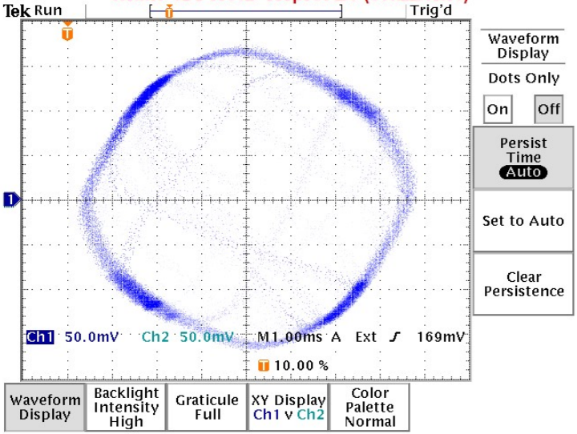

Figure 3: QPSK constellation by using X/Y display feature

Figure 4: Eye diagram for QPSK I & Q component (unfortunately, the screenshot file was corrupted, but the overall result looks similar to the one in figure 7)

**16-QAM:**

16-state quadrature amplitude modulation. Four I values and four Q values are used, yielding four bits per symbol 16 states because 24= 16. Data is split into two channels, I and Q. As with QPSK, each channel can take on two phases. However, 16-QAM also accommodates two intermediate amplitude values. Two bits are routed to each channel simultaneously, then applied to the respective channel’s modulator.

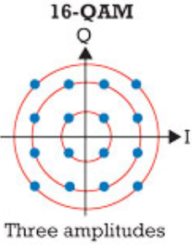

Figure 5: 16-QAM constellation plane

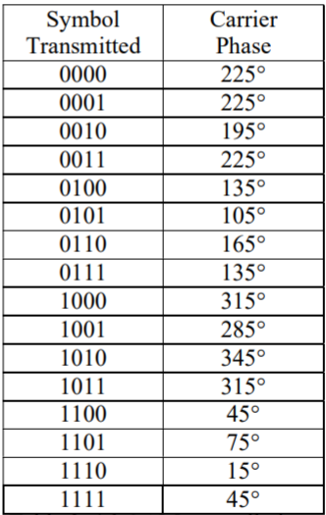

Table 3: 16-QAM constellations

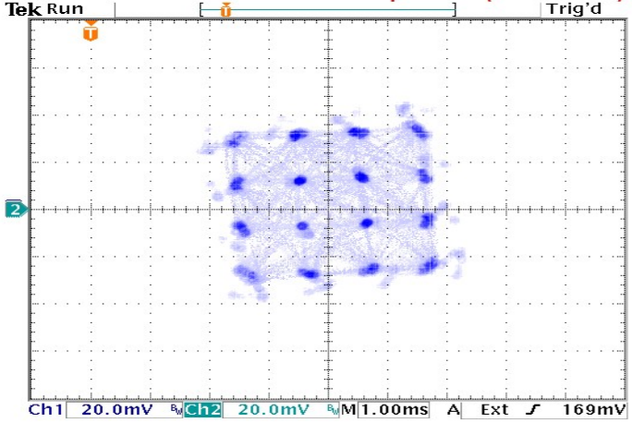

Figure 6: 16-QAM constellation by using X/Y display feature

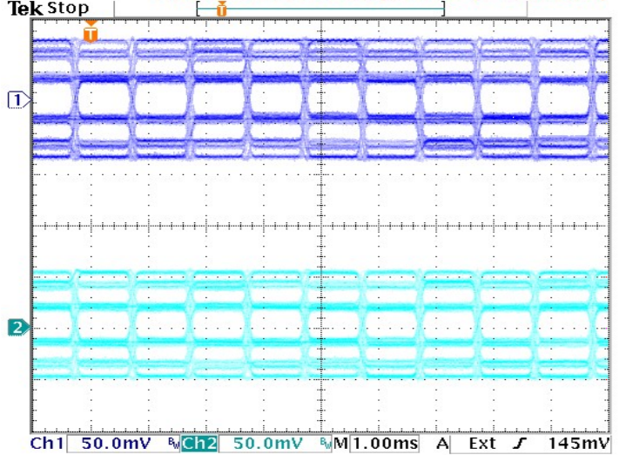

Figure 7: Eye diagram for 16-QAM I & Q component

**Wireless Transmission**

(1) Identify the missing blocks and draw the block diagram for the complete communication system.

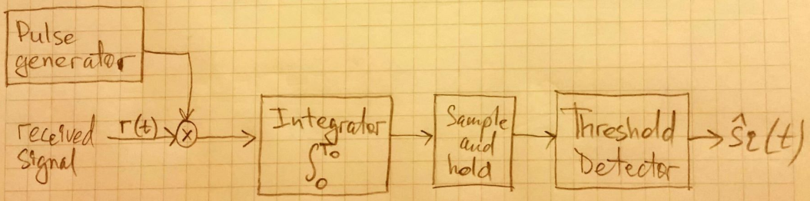

Figure 9: Communication system block diagram

(2) How can the missing blocks be implemented?

1. The modulated signal is multiplied by the same carrier with condition that the two
2. signals are in phase.
3. The result gets integrated.
4. The integrated result is sampled by a sample&hold circuit.
5. The amplitude of the samples is compared to a decision threshold.
6. If the amplitude is higher than the threshold the output is high, otherwise low.

**Software-Defined Radio (SDR)**

Software-defined radio (SDR) is a radio communication system where components that have been traditionally implemented in hardware (e.g. mixers, filters, amplifiers, modulators/demodulators, detectors, etc.) are instead implemented by means of software on a personal computer or embedded system. For our task, we investigated different images on a TV and saw how the bit patterns are represented. Below are a big collection of diagrams, which we collected from the lab:

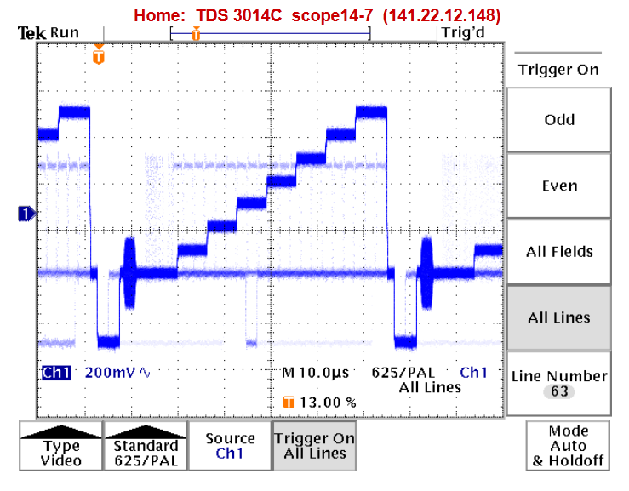

Figure 10: Bit pattern with a continuous spectrum of colors in an image represented by 7 distinct levels

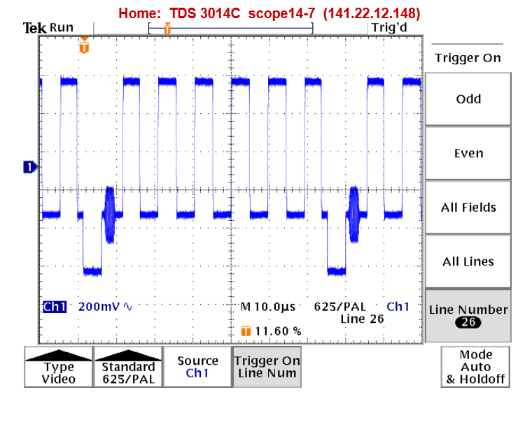

Figure 11: Plot with 6 white and 6 black peaks (a chessboard picture)

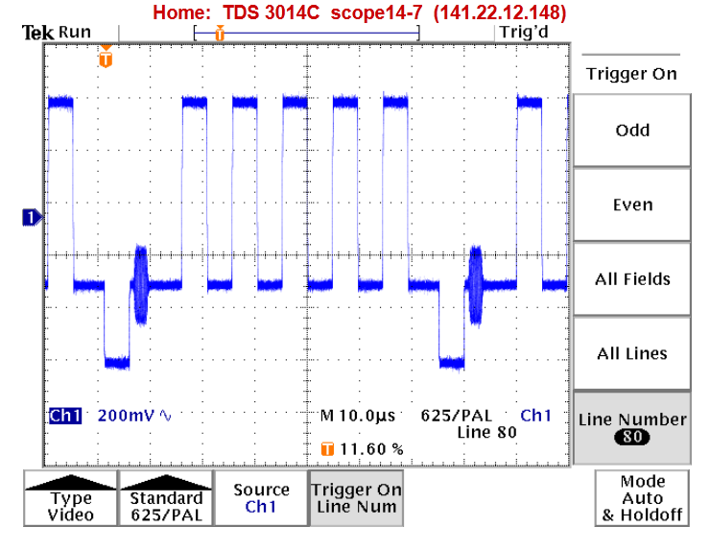

Figure 12: Similar plot, but with lines selection at Line 80

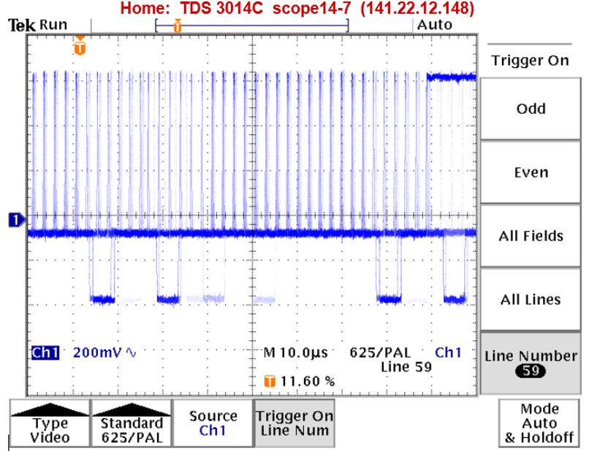

Figure 13: Bit pattern for an image containing square block with centers marked

with a white dot blocks

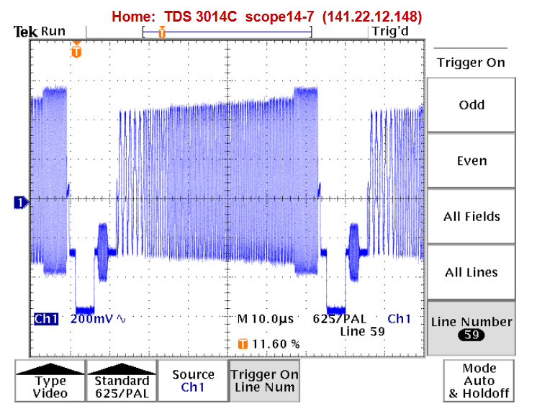

Figure 14: Bit pattern with black white with low frequency at start and then frequency increases (Line 59)

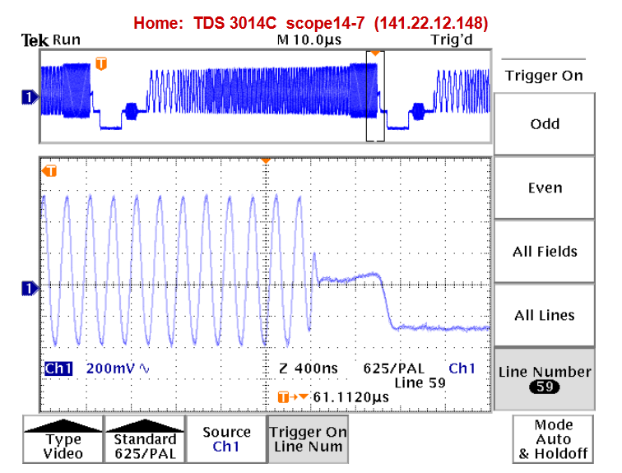

Figure 15: Same pattern with highest pixel frequency with frequency 5 MHz (Line 59) and using the “magnifier glass” function

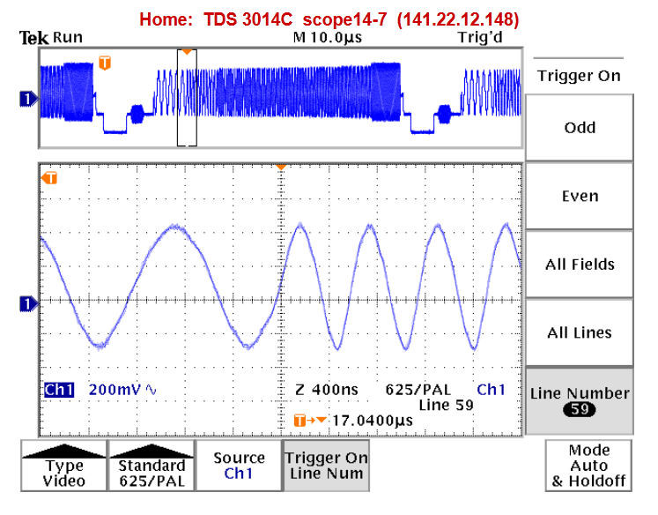

Figure 16: Same pattern with highest pixel frequency with frequency 5 MHz (Line 59) and using the “magnifier glass” function

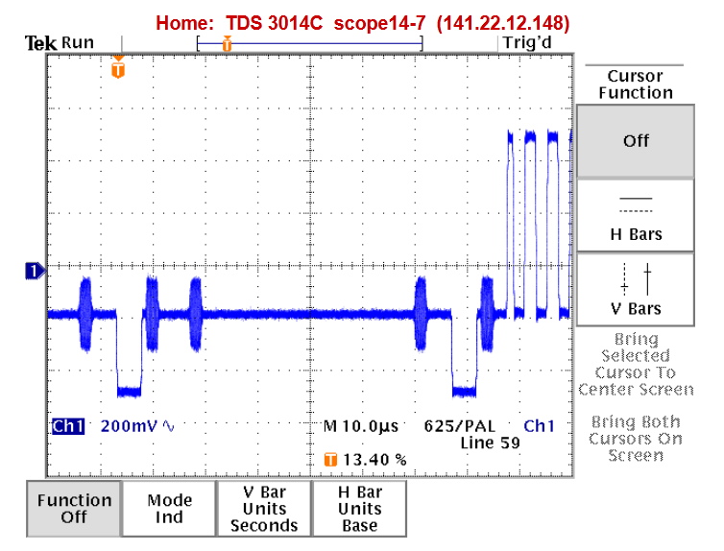

Figure 17: A part test picture’s bit pattern

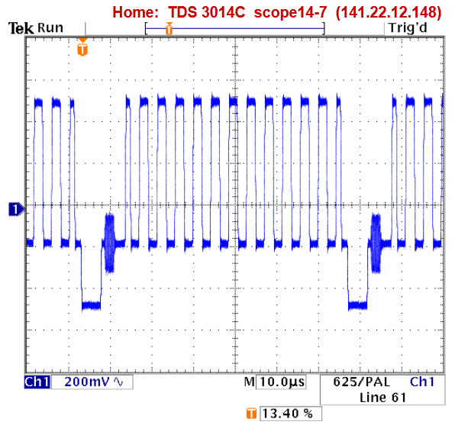

Figure 18: Between gray and white

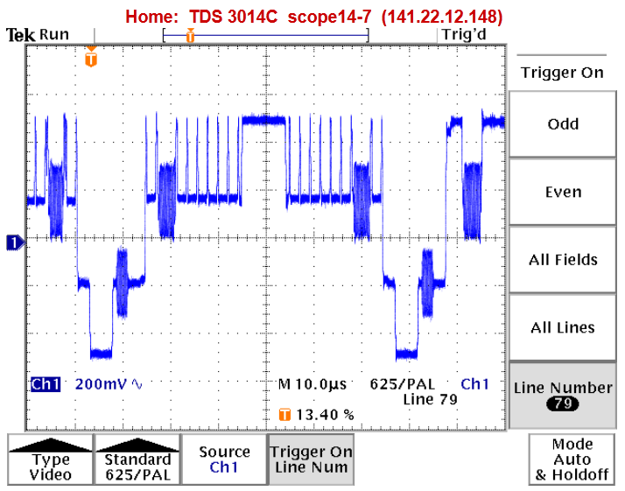

Figure 19: Near the PAL line

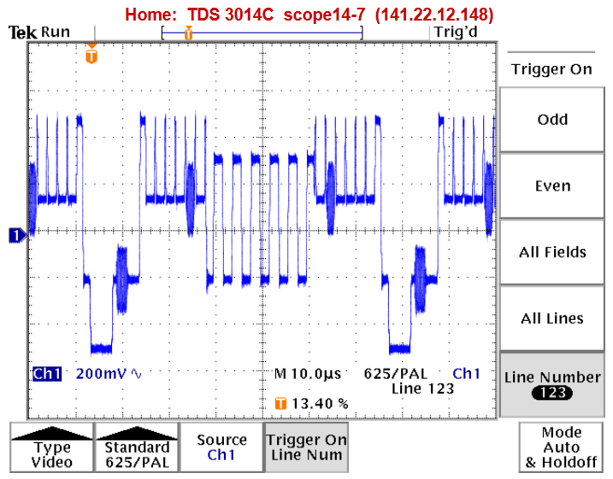

Figure 20: 5 diracs on both left and right sides

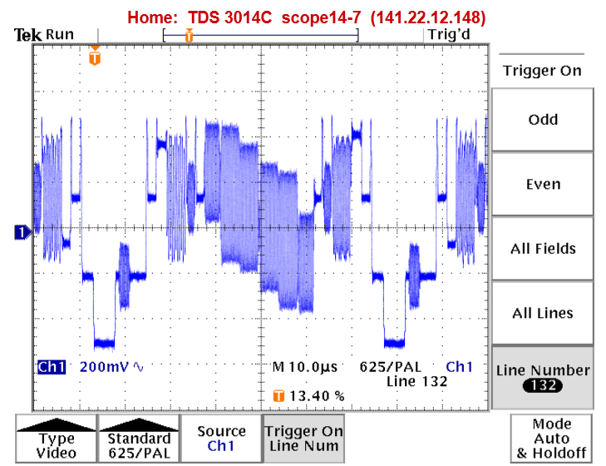

Figure 21: Different colors seen here: brown, blue, green, red, etc.

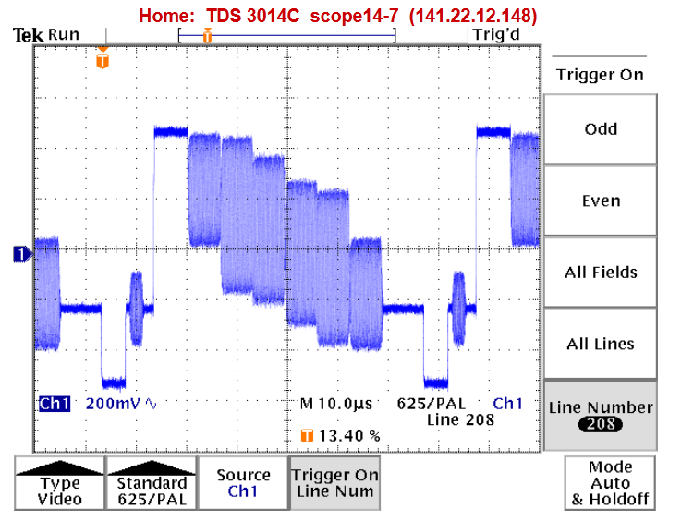

Figure 22: Marking colors with bits: black is 0 and white is 1

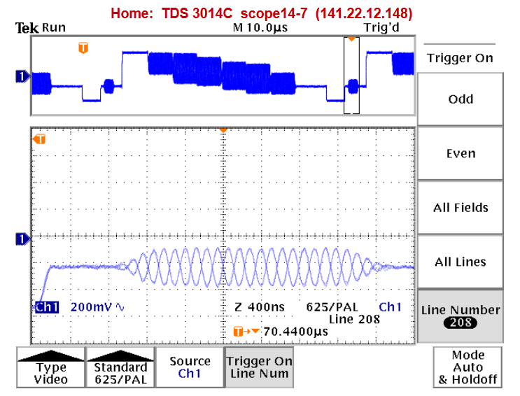

Figure 23: Colors burst with 5MHz frequency

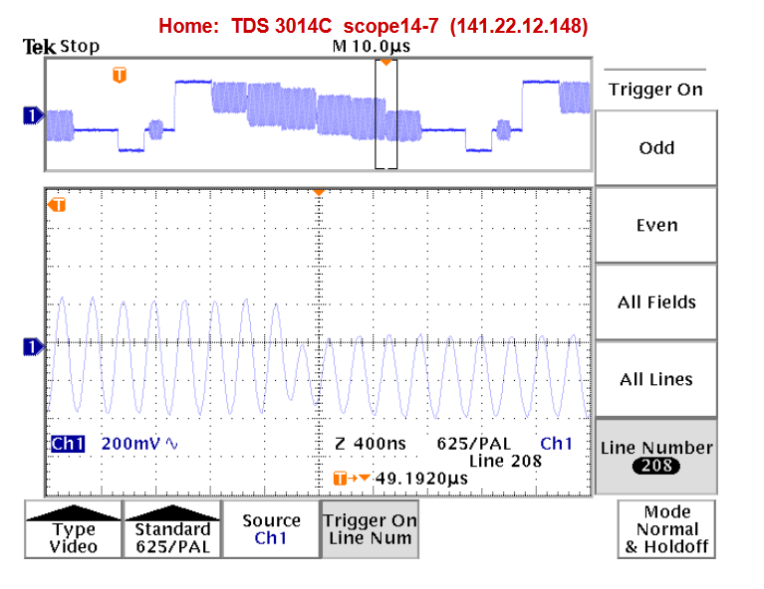

Figure 24: Changing from Red to blue with 5MHz frequency

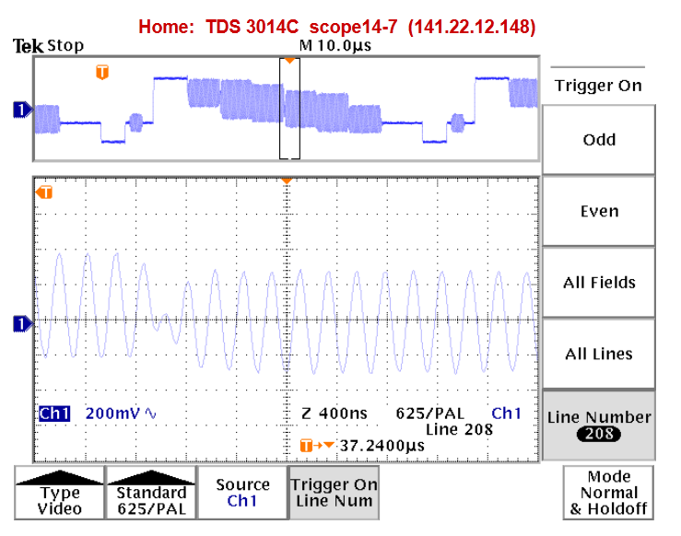

Figure 25: Here we have the phase shift and phase modulation with 5MHz frequency

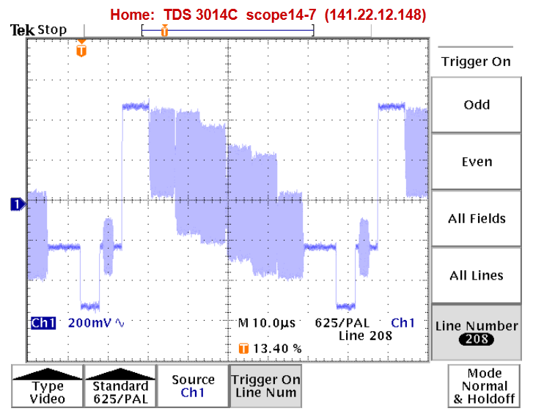

Figure 26: Here we have the phase shift and phase modulation with 5MHz frequency without magnifier

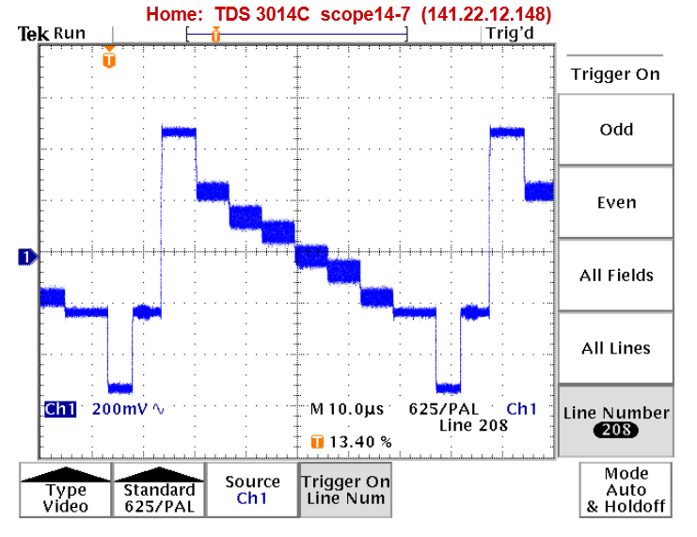

Figure 27: Here we have change in the intensity of the color with black and white color

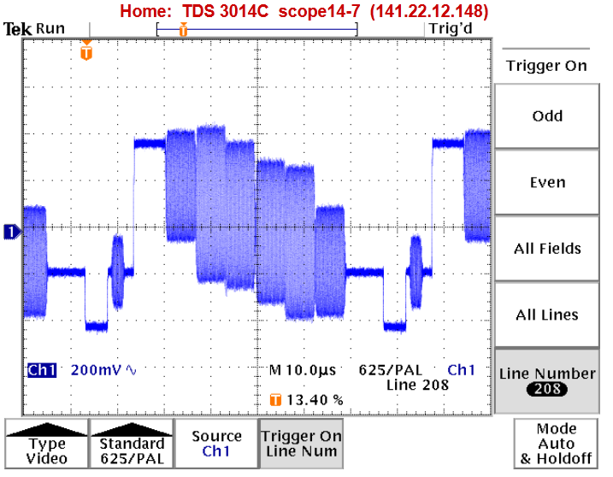

Figure 28: A phase jump in the last two red and blue

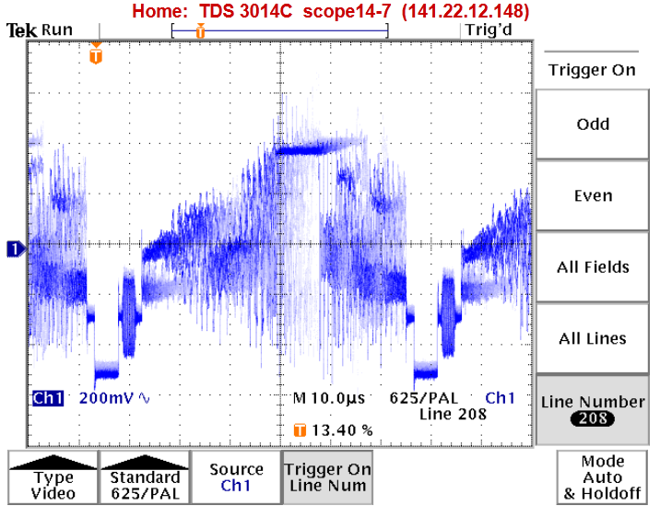

Figure 29: A camera picture

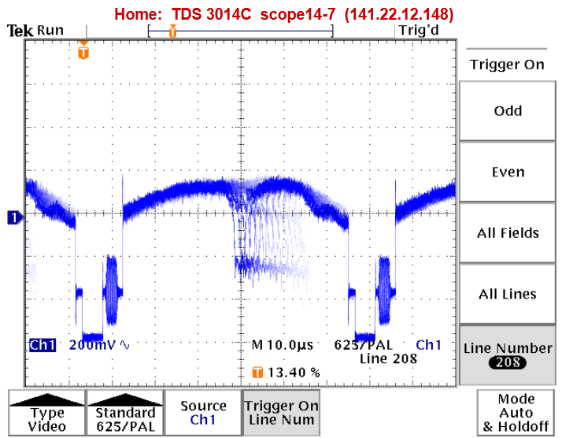

Figure 30: A camera being pointed at the ceiling

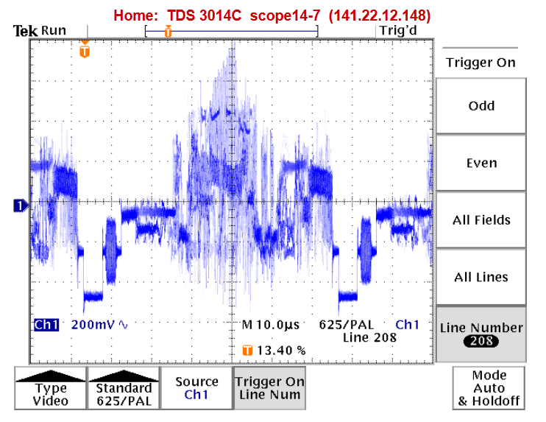

Figure 31: A bit pattern of our team’s photo (see the real photo below)

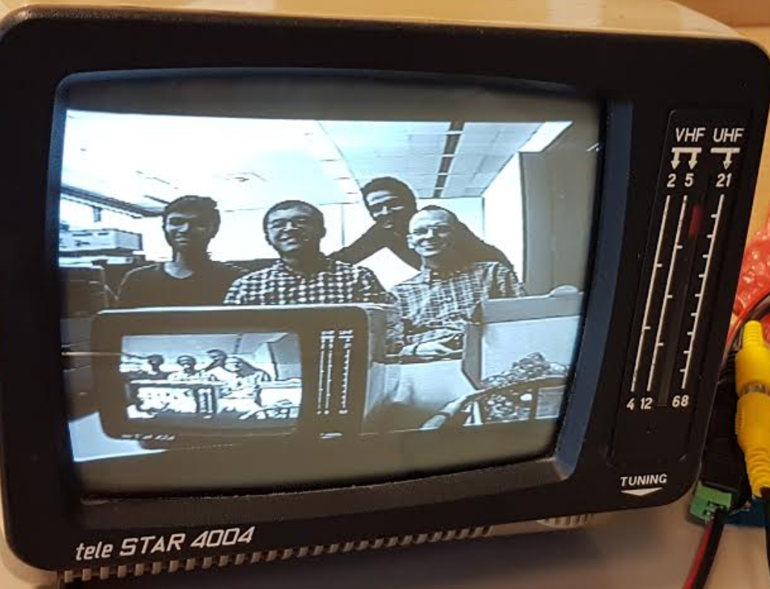

Figure 32: Our team’s photo =)